**Lab 4**

Set up the connectivity for computers behind NATs using a [free Google] VM with a public IP address as the lighthouse.

Set up the recommended cloud vm:

Go and nebula installed:

Configuring certificates:

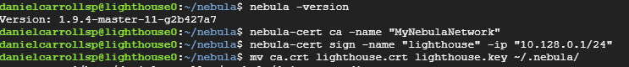

The files generated + the config.yaml (highlighted)

Successfully starting Nebula on the lighthouse vm using config.yaml

The private Nebula Ip is reachable from another nebula client but is not reachable through a non-Nebula client. However, the public Ip for the VM assigned by google is reachable from both. This tells me that my Lighthouse is up and running as intended.

Closer look: (10.128.0.2 = Nebula) (35.239.80.110 = Google cloud VM)

Shutting it down:

